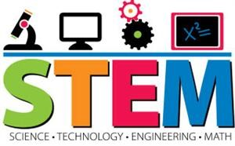

**AR Johnson Health Science and Engineering Magnet School**

**6th Grade STEM Research Class Syllabus**

**Ms. Perez**

In STEM Research class, students will participate in a variety of research reports and projects in any of the STEM fields. The goal of the class is to widen students’ knowledge of the various areas of STEM, to explore various careers in the STEM fields, and to look into the current trends in STEM. Students will be exposed to visiting presenters/speakers, will collect and analyze data, and will read and research various topics in order to complete projects, labs, reports, presentations, and much more. The twenty-first century is in need of well-educated people in the STEM fields. STEM Research class is a step in preparing students for the growing scientific and technological requirements of life in today’s society.

**Rules and Grading Procedures**

Please see the regular Earth Science syllabus for this information.

**Questions or Concerns**

Please email me at legoado@boe.richmond.k12.ga.us

**Supplies Needed for STEM Research Class:**

composition book /spiral notebook (separate one from Earth science) Pocket Folder

Blue or Black Pens and pencils Flash drive

Earbuds Agenda

Colored pencils, markers, or crayons Loose-leaf paper

- - - - - - - - - - - - - - - - - - - - - - - - - - - - - - - - - - -- - - - - - - - - - - - - - - - - - - - - - - - - - - - - - - - - - - Parent/guardians, please sign below and return to school to indicate you have seen this STEM Research syllabus. Thanks so much! This is going to be a great year at AR Johnson! 😊

Student’s Name: ______________________________

Parent/Guardian’s Signature: ________________________________________